TidyDisk
A product of American Systems

TidyDisk - A product of American Systems

TidyDisk, by American Systems, is a handy utility for cleaning unwanted files off your hard disk. It can clean temporary files, Internet cache files, and any other files you want removed. With TidyDisk, you can configure it to remove exactly the files you want deleted. And, you have a choice of removal methods. You can send files to the Recycle Bin, Delete them, Move them, put them in a ZIP file, or Permanently Delete them.

TidyDisk is fast and easy-to-use. It can scan all of your local drives and network drives as well. By removing all these unwanted files, TidyDisk helps give you more free disk space. Using the FREE companion program, EZ Scheduler, you can even schedule TidyDisk to run at any hour of the day or night. What a convenience! Schedule it and TidyDisk will run totally unattended, removing whatever files you've told it to. Requires Windows 95/98/NT 4.0 and 1.1 Megabytes of disk space. EZ Scheduler is available for FREE from the American Systems home page at http://www.americansys.com/ - Another fine product of American Systems.

Table of Contents

How to use TidyDisk 4
How do I select the drive(s) to clean? 4
How do I tell TidyDisk what files and folders to clean? 5
How can I view the file before I delete it? 9
How do I delete the files after I've scanned the drive? 10
How do I schedule a TidyDisk scan to run at a certain time? 11
What does Delete, Permanently Delete, Move to Recycle Bin, Zip and Move mean? 13
Come see us on the World Wide Web! 14
Contact Us: 14
Product Support: 16

How to use TidyDisk

TidyDisk, by American Systems, is a handy utility for cleaning unwanted files off your hard disk. It can clean temporary files, Internet cache files, and any other files you want removed. With TidyDisk, you can configure it to remove exactly the files you want deleted. And, you have a choice of removal methods. You can send files to the Recycle Bin, Delete them, Move them, put them in a ZIP file, or Permanently Delete them.

TidyDisk is fast and easy-to-use. It can scan all of your local drives and network drives as well. By removing all these unwanted files, TidyDisk helps give you more free disk space. Using the FREE companion program, EZ Scheduler, you can even schedule TidyDisk to run at any hour of the day or night. What a convenience! Schedule it and TidyDisk will run totally unattended, removing whatever files you've told it to. Requires Windows 95/98/NT 4.0 and 1.1 Megabytes of disk space. EZ Scheduler is available for FREE from the American Systems home page at http://www.americansys.com/ - Another fine product of American Systems.

How do I select the drive(s) to clean?

The drives you select are the drives that TidyDisk will scan. Simply click on the drives in the list you want TidyDisk to scan and click <Next>. See below.

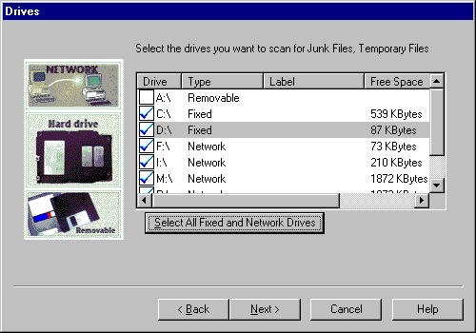

How do I tell TidyDisk what files and folders to clean?

You specify file patterns to delete by creating or modifying "profiles". TidyDisk comes with default profiles for file patterns most people have on their machine. See below:

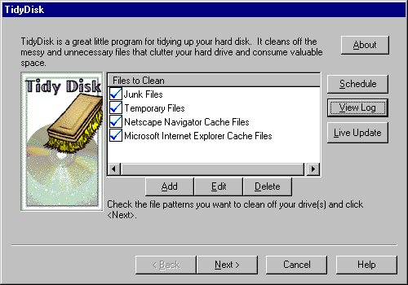

You may need to modify the example profiles to fit your PC. If so TidyDisk will warn you with the following message.

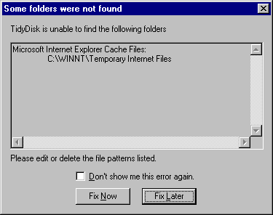
To create a new profile click the <Add> button on the main TidyDisk window. Clicking <Edit> will step you through editing a profile. If you don't need a profile anymore, click the <Delete> key.

Steps to create a profile:

1. Click the <Add> button on the main TidyDisk window. The following window will appear.

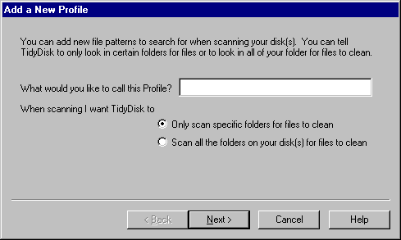

2. Type the name of the profile you are creating into the field called "What would you like to call this profile?".

3. Determine if you are creating a profile that will scan the entire disk or just search in a certain folder. If you intend for this profile to scan the entire disk, select "Scan all the folders on your disk(s) for files to clean". If you want to scan certain folders, select "Only scan specific folders for files to clean".

3a. If you selected "Scan all the folders on your disk(s) for files to clean", the following window will appear.

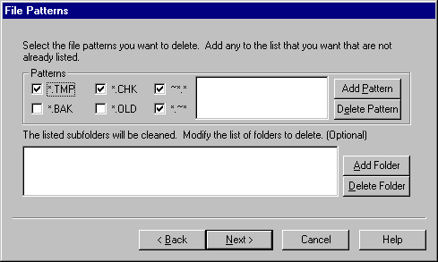

Add the file patterns you want to scan for by clicking the <Add Pattern> button. Enter patterns such as *.~at, ???.dat, ???.*, or any wildcard you can think of. Note: You will NOT be allowed to delete system files such as .EXE, .DLL, .DRV, .VXD and others. These files could render your system unusable, forcing you to either reinstall an application or worse, the entire operating system!

You can also specify subfolders to scan. Just click the <Add Folder> button. All the files in the subfolders you specify will be deleted.

3b. If you selected "Only scan specific folders for files to clean", the following window will appear.

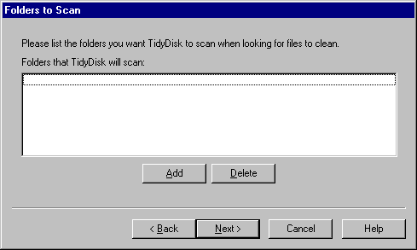

Just click the <Add> button to select the folder(s) to scan. All the files in the bfolders you specify will be deleted.

4. Now you will see the following window.

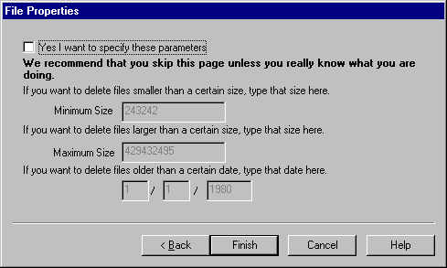

You can specify a minimum and maximum file size that you want to keep on your PC. You can also specify the oldest age of the files you want to keep.

Be very cautious with this window. You can potentially render your PC unusable if you don't know what you are doing.

How can I view the file before I delete it?

To view a file before you delete it click on the desired file and click the <Open> button. See the screen below. This will allow you to examine the file contents before you delete it. You may find that once you view a file that you want to keep it.

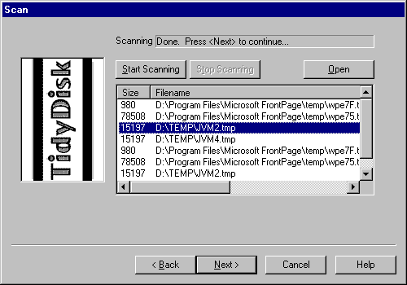

How do I delete the files after I've scanned the drive?

After scanning your hard drive(s) for files, it's time to delete them.

1. First you must select the files you want to delete. You do this by clicking on the files you want to delete. Or if you want to delete all the files, click <Select All>.

2. Now you can pick which deletion method you want to use.

What does Delete, Permanently Delete, Move to Recycle Bin, Zip and Move mean?

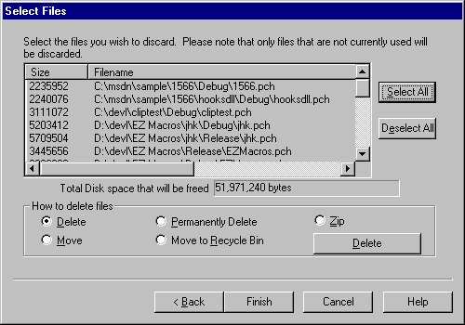

How do I schedule a TidyDisk scan to run at a certain time?

You may wish to schedule a TidyDisk scan to run at a particular time. We highly recommend EZ Scheduler from American Systems. EZ Scheduler is a FREE program from American Systems. It is not trialware, it is totally free. EZ Scheduler is specifially designed to work with TidyDisk and other American Systems products. It allows you to run tasks such as disk scans and many other types of programs Hourly, Daily, Weekly, Monthly, Once, When Windows Starts, Yearly and more. You can download this program from our web site at

http://www.americansys.com

Notice on the main TidyDisk window there is a "Schedule" button. When you have installed EZ Scheduler, the <Schedule> Button prompts you to choose how you want to run your macro, Hourly, Daily, Weekly, Monthly, Once, When Windows Starts, Yearly, etc. Then that's all you have to worry about.

If you already have a scheduler or just want to run a disk scan from the command line see the following example of the command to run.

"C:\Program Files\American Systems\TidyDisk\TidyDisk.exe" /r /p"Junk Files Temporary Files Netscape Navigator Cache Files Microsoft Internet Explorer Cache Files " /dCD /x1022 /m""

This command starts TidyDisk, runs the TidyDisk and scans for the following file patterns:

Junk Files
Temporary Files
Netscape Navigator Cache Files
Microsoft Internet Explorer Cache Files

TidyDisk scans the C: and D: drive for Junk Files and Temporary Files. See the /d switch.

/x1022 indicates that the files will be Deleted. The /m switch specifies the path to move the files to if you selected Zip or Move as the delete method.

Below are some screen shots of EZ Scheduler.

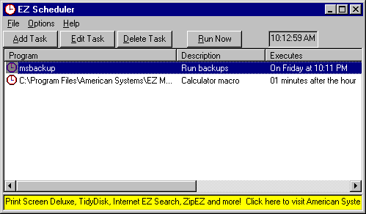

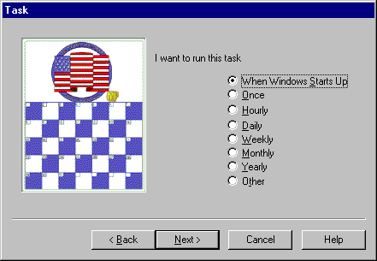

What does Delete, Permanently Delete, Move to Recycle Bin, Zip and Move mean?

Delete - Is the equivalent of using the Explorer or My Computer to delete a file. It is possible to "undelete" or restore these files after you delete them using 3rd party software provided by other vendors.

Permanently Delete - Deletes the file from your disk forever. It will not be possible to "undelete" or restore these files using any method.

Move to Recycle Bin - moves the files you select to delete to the Recycle Bin. This allows you to easily restore the files at a later time. If you want to use this feature, be sure that you do not have "Do not move files to Recycle Bin" checked in the Recycle Bin configuration. If you do have this checked, all the files sent to the Recycle Bin will be deleted.

Move - TidyDisk will prompt you for a folder to move your deleted files to. This will still give you access to your files but keep them all in one place should you decide to delete them later.

Zip - TidyDisk will prompt you for the name of a Zip archive file to send your deleted files to. This allows you to keep your deleted files in an archive rather than removing them forever.

Come see us on the World Wide Web!

At our web site you can :

. Place an order and get the right away!
. Download FREE evaluation versions of our software
. Learn more about ALL of our products
. Obtain technical support

Come see us at :

http://www.americansys.com

Contact Us:

American Systems
5424 Rufe Snow #320
Ft. Worth, TX 76180

Telephone: 817-485-6547
Fax: 871-485-2193
Email: info@americansys.com

Toll Free Order Line: 888-892-4310

Come see us on the web: http://www.americansys.com

TidyDisk 2.0 Order Form and Registration

To print this form, click on the 'File' menu, then click on the 'Print Topic' option.

Name ______________________________________________

Company _____________________________________________

Address ______________________________________________

City ____________________________ State ______ Zip __________

Phone (______) ______-________ Fax (______) ______-________ e-mail ___________________

Important: Is this your first product from American Systems? ( )Yes ( )No

_____ Number of Copies of TidyDisk

x $19.95 = $ ____________ (TEXAS residents add 8 1/4% sales tax.)

American Express ( ), Visa ( ) or MasterCard ( ) Number ________________________________ Exp. Date ___________

Signature: _________________________________________________

Make checks and money orders payable to American Systems.

P.O.s for more than $100.00 are welcome! Bulk pricing is available!

Call us toll free at 1-888-892-4310

Mail, or Fax your check or credit card details to :

American Systems
5424 Rufe Snow #320
Fort Worth, TX 76180
Care of Windows Utilities Division
Fax:(817)485-2193

or Compuserve: GO SWREG #16074
or Order Online at http://www.americansys.com and get the software right away!

Where did you get your evaluation copy from?

( ) Internet
( ) Vendor
( ) CD-ROM

( ) Friend
( ) Other Name of source ___________________________________________

Note: Prices are effective April 1, 1997 and are subject to change. Please enclose any comments you have.

Product Support:

American Systems provides user support to registered versions via mail, and/or telephone.

American Systems will answer questions and resolve serious bugs for the first three months after registration. For problems involving a specific hardware or software environment or feature, we may choose not to modify the program. In that case, if a problem is reported within three months after purchase, then we shall offer to refund the user's purchase price.

If a bug prevents you from evaluating TidyDisk during the first 30 days (prior to purchase), American Systems will attempt to assist but is not under obligation to resolve issues beyond our control.

Phone:
(817)485-6547

Fax:
(817)485-2193

CIS:
support@americansys.com

World Wide Web:

http://www.americansys.com

Address:
American Systems
5424 Rufe Snow #320
Fort Worth, TX, 76180
Care of Windows Utilities Division

Please share the evaluation version of TidyDisk with others for the purpose of evaluation as long as it is unaltered and distributed in its entirety.

