PC Remote

PC Remote is an intuitive, multi-faceted program that lets you access another computer from a remote location. Designed to be flexible and inexpensive, PC Remote lets you access another computer across a network, on the Internet, on the computer serial ports, or through a modem connection. Now you have multiple ways to access the data you need. PC Remote is the low cost solution for accessing remote computers.

Who has access to the host (remote) computer is determined by you and is totally secure.
You can assign others a username, password, and determine whether or not they can transfer files. This makes it easy for you to allow a family member or coworker to access the remote computer. You can clearly see everything on the other screen and have full control of the keyboard and mouse. You can access files on your work computer from home and quickly download them.

Copyright © 1999, American Systems, All rights reserved.
Table of Contents

How do I connect to another computer over the network, modem or serial port? 3
Connecting to your partner PC over a modem 5
Connecting to your partner PC over the network or Internet 6
Connecting to your partner PC over a serial port (aka COM Port) 7
How do I save a connection that I use frequently? 8
How do I allow others to remotely control my PC? 9
How do I control who uses my PC and who does not? 10
How do I send a file to a remote computer? 11
How do I retrieve a file from the remote computer? 12
How do I create a macro so that I can automate keystrokes I type over and over again? 14
How do I know who is connected to my computer? 17
How do I schedule a session and run a macro that will run unattended? 18
How do I get the latest version of PC Remote? 20
What is "Use Feed Load"? 21
How do I increase the speed of my screen refresh? 22
Come see us on the web 23
PC Remote 1.0a Registration 24
Product Support 25

How do I connect to another computer over the network, modem or serial port?

For starters, both computers need to have PC Remote installed. One is set up to allow others to control the PC. The other is set up to control someone else’s PC.

You can connect to another PC over a networks, modem, serial port, or Internet.

To connect to another computer double click on "Connect to a Remote Computer" as seen below.

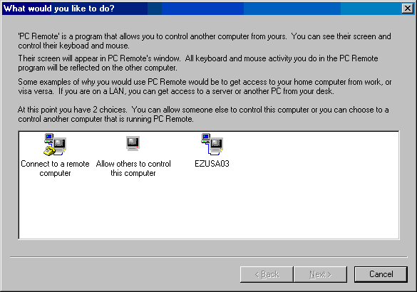

The following window appears. (continued)

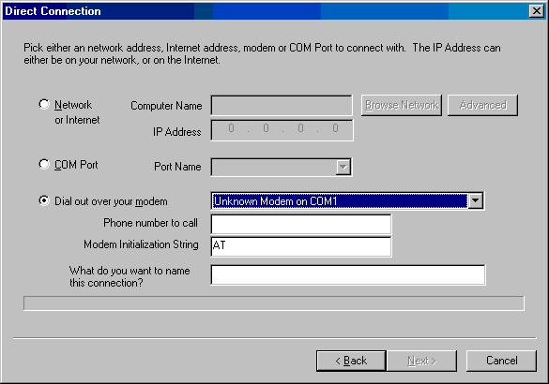

At this point you and the partner computer must agree on which method you will use to communicate with each other. You can choose your network, modem or serial port (aka COM Port).

Connecting to your partner PC over a modem

The window above shows what the modem selection looks like. PC Remote will list all the modems you have installed in the drop down list. You then specify the phone number of the partner.

Choose the modem you want, or use the one selected for you. Type the phone number of your partner's modem number. You can alter the Modem Initialization String if you really want to. But we recommend you do not unless you really know what you are doing.

A handy feature of PC Remote is you can save your connection under a name. Let's say you are connecting to your partner's PC and your partner's name is Brad. You can type "Brad's PC" in the "What do you want to name this connection". And PC Remote will remember the configuration for "Brad's PC" from now on. The next time you want to connect to Brad's PC all you have to do is double click on the "Brad's PC" icon instead of going through this process. For more information see How do I save a connection I use frequently? See below.

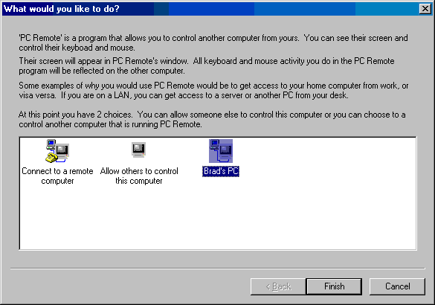

Connecting to your partner PC over the network or Internet

The following window shows what the network selection looks like.

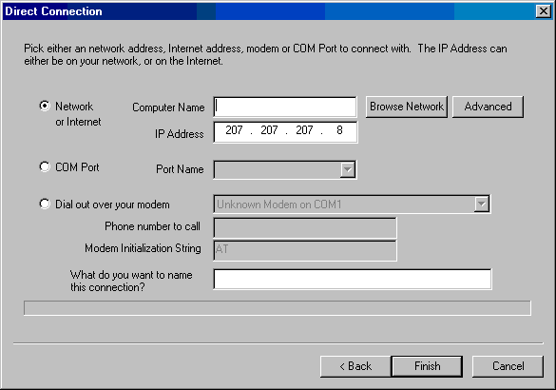

You have a couple of ways to go about this. If you type the computer name of the remote computer PC Remote will automatically lookup the IP Address of that computer. You can also click <Browse Network> to search the network for other computers running PC Remote.

If you want to connect over the Internet to your partner, you must type their IP Address and leave the Computer Name field blank.

When you are done click <Finish> and PC Remote will connect to your partner.

Connecting to your partner PC over a serial port (aka COM Port)

The following window shows what the COM Port selection looks like.

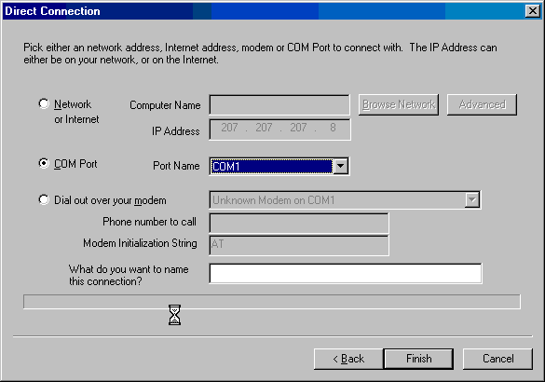

PC Remote automatically determines which COM Ports are available on your PC and lists them for you. Just choose the port that your serial cable is hooked up too and click <Finish> to connect to the other computer.

How do I save a connection that I use frequently?

A handy feature of PC Remote is you can save your connection under a name. Let's say you are connecting to your partner's PC and your partner's name is Brad. You can type "Brad's PC" in the "What do you want to name this connection". And PC Remote will remember the configuration for "Brad's PC" from now on. The next time you want to connect to Brad's PC all you have to do is double click on the "Brad's PC" icon instead of going through this process. See below.

The next thing you will see is the "Connecting" window.

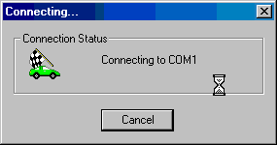

If you are connecting over a modem, you will see the word "Dialing...". If you are connecting over a network or the Internet, you'll see the IP Address of the computer you are connecting to.

How do I allow others to remotely control my PC?

To allow others to control your PC, click on "Allow others to control this computer" as seen below, then click <Next>.

Choose which method you will use to wait for an incoming person to control your PC. Please note that you can restrict who uses your PC by clicking the <Users> button or by clicking the <Users> button on the main PC Remote window.

You should work with your partner to know which communication method you will use, network, Internet, modem or serial port (COM Port).

If you select COM Port PC Remote automatically determines which COM Ports are available on your PC and lists them for you. Just choose the port that your serial cable is hooked up to.

If you select Modem PC Remote will list all the modems you have installed in the drop down list. Just choose the modem you want to use. Be sure your partner knows the correct modem phone number to dials.

How do I control who uses my PC and who does not?

When someone connects to you, they will be asked to type their user name and password. It will be checked against this list. If their user name and password do not match what you have specified in this list, they will not be allowed to access this PC.

If you want unrestricted access to your PC, just check the "Allow everyone..." box and click <Close>.

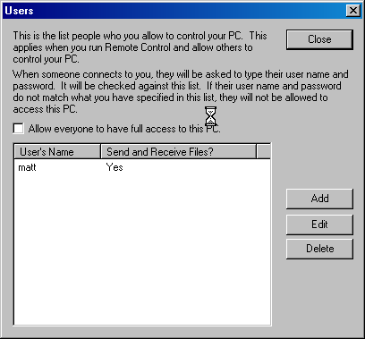

To add users, click the <Add> button. You will see the following window.

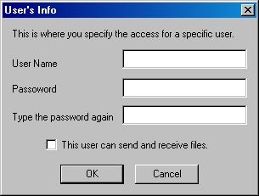

Type the user's name and password here. Type the password twice to make sure you typed it correctly.

If you want this user to be able to send and receive files to and from your PC, check the "This user can send and receive files" box.

How do I send a file to a remote computer?

Click the 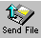 button on the toolbar.

The following window appears.

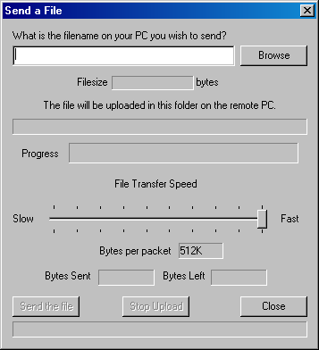

Click <Browse> to find the file on your PC you want to send to the remote PC.

Then click the <Send File> button to send it. If you find that the file transfer is too slow for your taste, click the  button on the main toolbar. This will stop the screen refreshing and give more time to your file transfer.

You can also adjust the number of bytes sent per "chunk" or "packet" by adjusting the slider bar up and down.

How do I retrieve a file from the remote computer?

Click the  button on your toolbar. The following window appears.

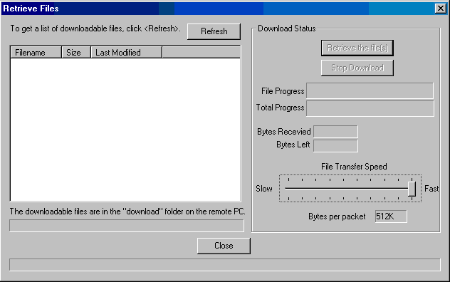

To see a list of files you can download click the <Refresh> button. A list like the following appears.

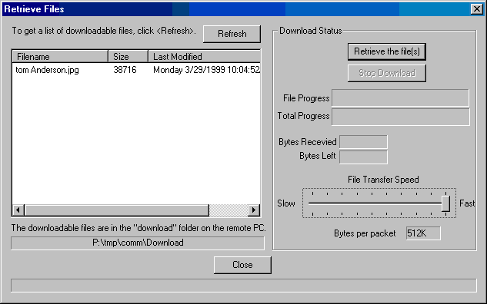

Click on the file you want download and click the <Retrieve file(s)> button.

If you find that the file transfer is too slow for your taste, click the button on the main toolbar. This will stop the screen refreshing and give more time to your file transfer.

You can also adjust the number of bytes sent per "chunk" or "packet" by adjusting the slider bar up and down.

How do I create a macro so that I can automate keystrokes I type over and over again?

Macros are handy when you wish to automate tasks that you do over and over again. They are also useful when you have to schedule a session to run at regular time intervals.

Click the 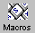 button on your toolbar. The following window appears.

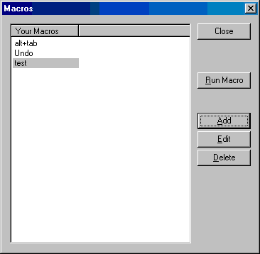

To create a new macro click <Add>. The following window appears. (continued)

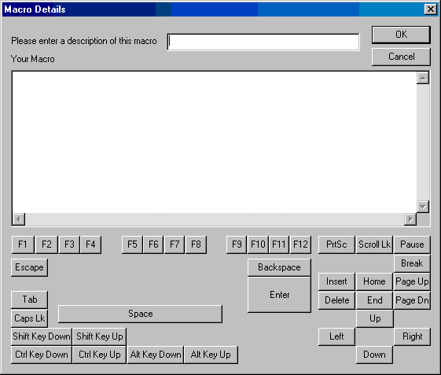

Type a name for the macro then move down to the "Your Macro" field. This is where you actually type what keystrokes will be played when the macro is played.

Here is a sample macro. (continued)

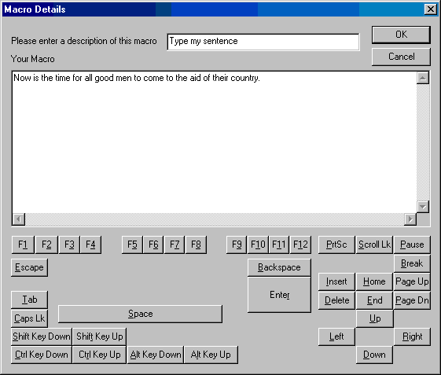

This macro just type the sentence "Now is the time for all good men to come to the aid of their country." when ran.

If you find that you need more macro functionality, we suggest you try EZ Macros. You can get EZ Macros at www.americansys.com. You can also download a trial version at www.americansys.com.

How do I know who is connected to my computer?

When you allowing others to control who is connected to you, you see the following window.

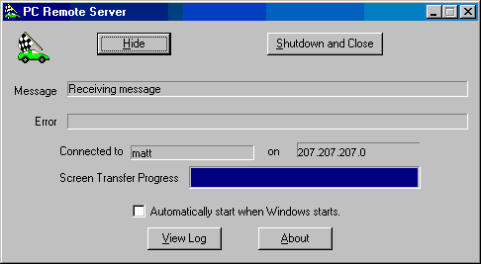

On this window you see who is connected to you, their address, or modem or port and what is happening at that exact moment.

How do I schedule a session and run a macro that will run unattended?

You may find that on a periodic basis that you are doing the same task over and over again. In this case it will be helpful to you to schedule a macro. First, click the 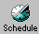 button. If you do not already have EZ Scheduler installed, you will be prompted to visit our web site and download it. It is a free add on for many of our products.

Once you have EZ Scheduler installed, the window you will see next is:

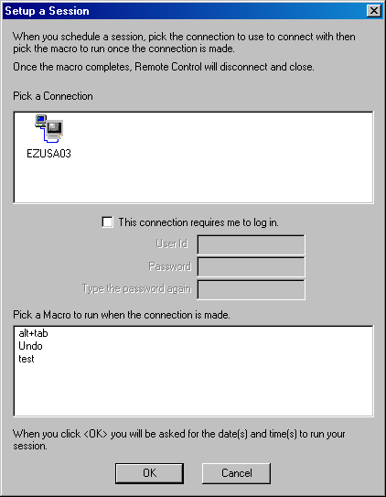

You must pick a connection you have previously saved and a macro to execute when PC Remote starts off.

Next you will be asked when you want to run the macro. (continued)

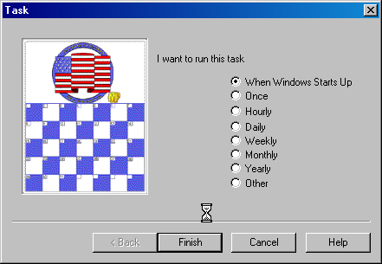

Next, just follow the on screen instructions to set up the times and dates (where they apply).

When EZ Scheduler runs PC Remote the connection will automatically be made. Once connected the macro will run. When the macro completes, PC Remote will hang-up and close.

How do I get the latest version of PC Remote?

PC Remote has a really neat feature built in called "Live Update". Live Update will connect to the American Systems web site using your Internet connection and retrieve the latest upgrade and install it for you.

Just click on Help..Live Update.

The following window will appear.

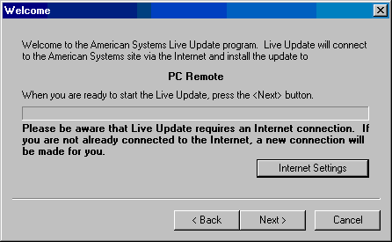

If you already have the most up to date version you will see the following.

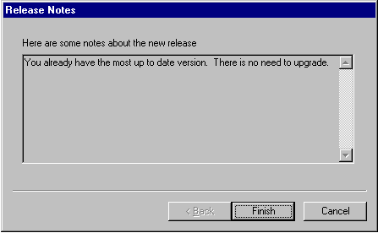

Otherwise, follow the instructions on the screen to install the new version.

What is "Use Feed Load"?

When you enable "Feed Load" you are asking that you display the screen image in "chunks" as it comes across your connection. You will see it appear in strips until you get a complete image. Then the next screen image begins to fill in over it.

When you disable "Feed Load", PC Remote downloads the entire screen then paints it.

Disabling Feed Load results in faster screen refreshing. Whereas enabling feed load gives you more immediate results. Try them both and see which you like best.

How do I increase the speed of my screen refresh?

In one of two ways. Your first choice is to work with the Feed Load settings. Read What is "Use Feed Load"?

You can also work with the Image Quality in the File..Preferences. You can lower the image quality of your screen image and increase the screen refresh speed. Play with it and see what you like.

Come see us on the web

At our web site you can:

. Download the fully functional EZ Scheduler for FREE. No strings attached.
. Download FREE evaluation versions of our software
. Learn more about ALL of our products
. Obtain technical support

Come see us at:

http://www.americansys.com

PC Remote 1.0 Registration

Name ______________________________________________

Company _____________________________________________

Address ______________________________________________

City ____________________________ State ______ Zip __________

Phone (______) ______-________ Fax (______) ______-________

Email ___________________

Important: Is this your first product from American Systems? ( )Yes ( )No

Mail, or Fax or email us at:

American Systems
5424 Rufe Snow #320
Fort Worth, TX 76180
Care of Windows Utilities Division
Fax:(817)485-2193
sales@americansys.com

or Order Online at http://www.americansys.com.

Where did you get PC Remote?

Name of source ___________________________________________

Product Support

American Systems provides user support to registered versions via mail, and/or telephone.

American Systems will answer questions and resolve serious bugs for the first three months after registration. For problems involving a specific hardware or software environment or feature, we may choose not to modify the program. In that case, if a problem is reported within three months after purchase, then we shall offer to refund the user's purchase price.

If a bug prevents you from evaluating PC Remote during the first 30 days (prior to purchase), American Systems will attempt to assist but is not under obligation to resolve issues beyond our control.

Phone:
(817) 485-6547

Fax:
(817) 485-2193

Internet:
support@americansys.com

Address:
American Systems
5424 Rufe Snow #320
Fort Worth, TX, 76180
Care of Technical Support

Please share the evaluation version of PC Remote with others for the purpose of evaluation as long as it is unaltered and distributed in its entirety.

